YTuber Victory

## A Major Project-I Report (IT-706) Section A

in partial fulfillment for the award of the degree

of

**BACHELOR OF ENGINEERING**

**IN INFORMATION TECHNOLOGY**

**Submitted by:-**

**Akshat Kumar 0103IT181016**

**Guide Name:**

**Prof. Parmalik Kumar**

at

**LAKSHMI NARAIN COLLEGE OF TECHNOLOGY KALCHURI NAGAR, RAISEN ROAD, BHOPAL (INDIA) - 462022**

**SESSION AUGUST-DECEMBER 2021**

# DECLARATION

I hereby declare that the project entitled “**YTuber Victory**” submitted for the B.Tech.(Information Technology) degree is **our** original work and the project has not formed the basis for the award of any other degree, diploma, fellowship or any other similar titles.

**Signature of the students with date**

### Place: (1) …………………………...

**Date:**

**(2)…………………………… (3)……………………………**

**CERTIFICATE**

This is to certify that the project titled “**YTuber Victory**” is the bonafide work carried out by **Akshat Kumar (0103IT181016 )** student of B.Tech.(Information Technology) of Lakshmi Narain College of Technology, Bhopal affiliated to Rajiv Gandhi Proudyogiki Vishwavidyalaya, Bhopal, Madhya Pradesh (India) during the academic year 2021-2022, in partial fulfillment of the requirements for the award of the degree of Bachelor of Engineering (**Information Technology** ) and that the project has not formed the basis for the award previously of any other degree, diploma, fellowship or any other similar title.

**Signature & Seal of HOD, Information Technology Signature of the Guide with Date**

### Lakshmi Narain College of Technology, Bhopal

**Signature & Seal of Principal Lakshmi Narain College of Technology, Bhopal**

# ABSTRACT

Our project is named as “**YTuber Victory**”, this is basically a Web based Application similar to the various Business Web applications on the internet today, with some different focus on the objective. The main objective of building this project YTuber Victory is to develop full-fledged web application That will help business owner to deal with you tubers.

As most of the people lives busy life so their needs depend on the internet it is convenient to the people and reduces man power. Our application lets business owner and You Tuber to deal with each other.

As their are many business applications but none of them are focusing on this section so, here we are centralized on this through the application.

# ACKNOWLEDGEMENT

It is with great reverence that we express our gratitude to our guide “**Prof. Parmalik Kumar**” Department of Information Technology, Lakshmi Narain college of technology, Bhopal (M.P.) for his precious guidance and help in this project work. The credit for the successful completion of this project goes to his keen interest timing guidance and valuable suggestion otherwise our endeavor would have been futile. We sincerely thank “**Prof. Parmalik Kumar**” for his guidance and encouragement in carrying out this project work. We owe to regard to “**Prof. Sushil Kumar**” Head of Department of Information Technology for his persistent encouragement and blessing which were bestowed upon us. We owe our sincere thanks to honorable Principal “**Dr. Kailash Shrivastava**” for his kind support which he rendered us in the envisagement for great success of our project**.**

# List of Figure

## Figure name Page no

Figure 4.1.1 (Home Page) 8

Figure 4.1.2 (Home Page) 8

Figure 4.1.3 (Home Page) 9

Figure 4.2.1 (Signup Page) 10

Figure 4.2.2 (Login Page) 10

Figure 4.3.1(About Us) 11

Figure 4.4.1 (Tubers) 13

Figure 4.5.1 (Description) 13

Table of Contents

Title Page i

Declaration of the ii

Student

Certificate of the Guide iii

Abstract iv

Acknowledgement v

List of Figures vi

### INTRODUCTION*

* 1. Problem Definition
  2. Project Overview/Specifications
  3. Software Specification

### LITERATURE SURVEY

* 1. Existing System
  2. Proposed System
  3. Feasibility Study

### SYSTEM ANALYSIS & DESIGN

* 1. Requirement Specification
  2. Flowcharts / DFDs / ERDs
  3. Algorithms and Pseudo Code

### RESULTS / OUTPUTS

1. **CONCLUSIONS / RECOMMENDATIONS**
2. **REFERENCES**
3. **APPENDICES**
   1. Details of software/simulator if any
   2. Steps to execute/run/implement the project
   3. Coding if any

# INTRODUCTION

## Problem Definition

In this project we are focusing on the Business web Application Which is a platform for business deals. Here You Tubers and Business owners collaborate with each other and business owner according to his/her choice can choose You Tuber and can request the You Tuber for the product promotion and if the You Tuber agree with the deal then business owner give money to the You Tuber for their product promotion. Here we are trying to help business owner and You Tubers in this section and their effort are totally depend upon the internet.

## Project Overview

Project basically divided into of 5-6 pages

1. Home page

Home page contains the welcome screen to the user who tells the user about are web App It also contains Signup and login page.

1. Signup and login page

When the user wants to enter in our application, they first signup or login and then move further

in our web App.

1. payment Gateway

This is basically highly secured payment gateway where user can do the payment of their Products. With various payment option provided on the page.

## Software Specification

In order to build the project, we use Visual Studio Code to setup both frontend and backend. Vs code should contain following extensions: -

* Pillow Module:- it is use for store images.
* Django 3.1.1: - Django is used for communicate with data base and server.
* Python 3.9 :- for Compiling python.
* PostgreSQL :- It is for Database.
* Html5:- It is help for making GUI(graphical user interface).
* CSS3:- It is to decorate your GUI(graphical user interface).
* Bootstrap4 :- for Designing and Animation.

# LITERATURE SURVEY

## Existing System Survey

* During this survey we have seen many web Application helping people to fulfill their basic needs of their livelihood. Whether in case of electronics likes Mobiles, PC’s, television A.C., or in case of clothing.
* Many of them focusing on particular section like Myntra (focusing on the wardrobe section), lenskart, etc.
* Many of them focusing on the all the required resources in day-to-day life.
* They are flipkart, amazon, etc.
* There are so many business platforms which focuses on so many aspects but no one was focusing in this particular section of collaboration of You Tubers and Business Owners that’s why we came with this platform so that we can help Business owners and You Tubers in this particular section.

## Proposed System

* We identified the problem that all the existing system not focused on this type of business platform.
* Many business applications now a days focused towards different types of sales like electronic parts, vehicles, etc.
* We introduce Business platform with best You Tubers for product promotions & at affordable prices so that it will be feasible for business owners.

## Feasibility study

* Our web-app is easy to access & user friendly.
* It will provide best out of the best You Tubers.
* They will promote products at most affordable prices.
* By this feasible study it will go long ahead in future.

# SYSTEM ANALYSIS & DESIGN

## Requirement Specification

Internet Connectivity

Devices like mobile (Android or iOS or any other) & PC’s etc. Devices also contain updated browser.

## Flow chart

Home Page

Signup

Login

Dashboard

Contact Us

Tubeers eeeeee bberrs

Explore

* 1. **Algorithms and Pseudo Code**

It contains Signup and login button to move further in Application.

* + 1. For Signup required credentials user name, first name, last name, email, password, phone no.,

Address, etc. goes to database. By the help of models # Create your models here.

class Register(models.Model): username=models.CharField(max_length=200,primary_key=True) fisrt_name=models.CharField(max_length=100) last_name=models.CharField(max_length=100) email=models.EmailField() phone=models.CharField(max_length=10 ,null=True) address=models.CharField(max_length=300 ,null=True)

def _str_(self):

return self.username

class Product(models.Model): name=models.CharField(max_length=254,primary_key=True) price=models.FloatField()

stock=models.IntegerField() delivery=models.FloatField(default=0)

des_line1=models.CharField(max_length=500,default="",null=True,blank=True)

des_line2=models.CharField(max_length=500,default="",null=True,blank=True)

des_line3=models.CharField(max_length=500,default="",null=True,blank=True) des_line4=models.CharField(max_length=500,default="",null=True,blank=True) des_line5=models.CharField(max_length=500,default="",null=True,blank=True) img1=models.ImageField(null=True,blank=True) img2=models.ImageField(null=True,blank=True) img3=models.ImageField(null=True,blank=True) img4=models.ImageField(null=True,blank=True) img5=models.ImageField(null=True, blank=True)

def _str_(self):

return self.name

class Tubers(models.Model):

pass

* + 1. For login it only required user name and password.

Login is one done with full security of the user.

class CreateUserForm(UserCreationForm):

class Meta:

model=User fields=['username','email','password1','password2','first_name','last_name']

* + 1. After when user successfully login into the Application then goes You Tubers page where they

can select You Tuber of their choice. @login_required(login_url='login') def products(request):

return render(request,'products/imagespage.html')

def logoutUser(request):

logout(request)

return redirect('login')

# RESULTS

Homepage

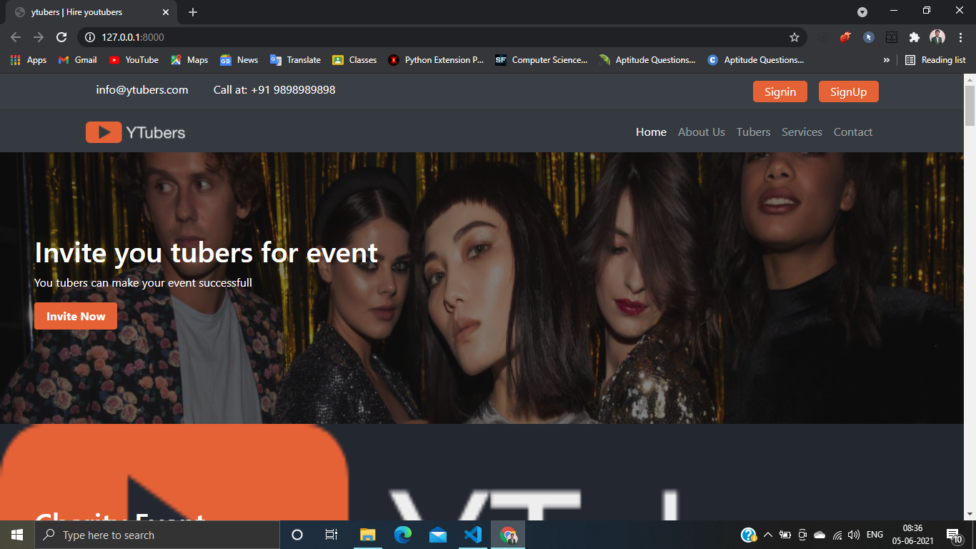

Figure: 4.1.1

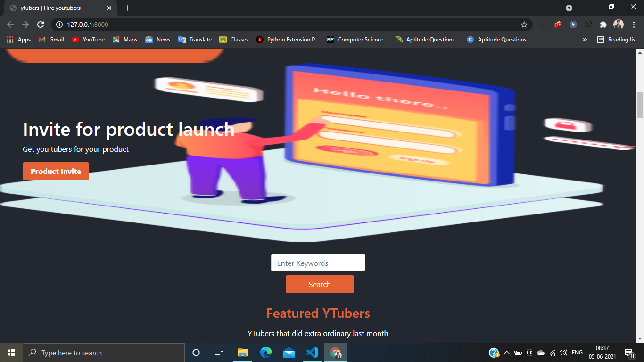

Figure 4.1.2

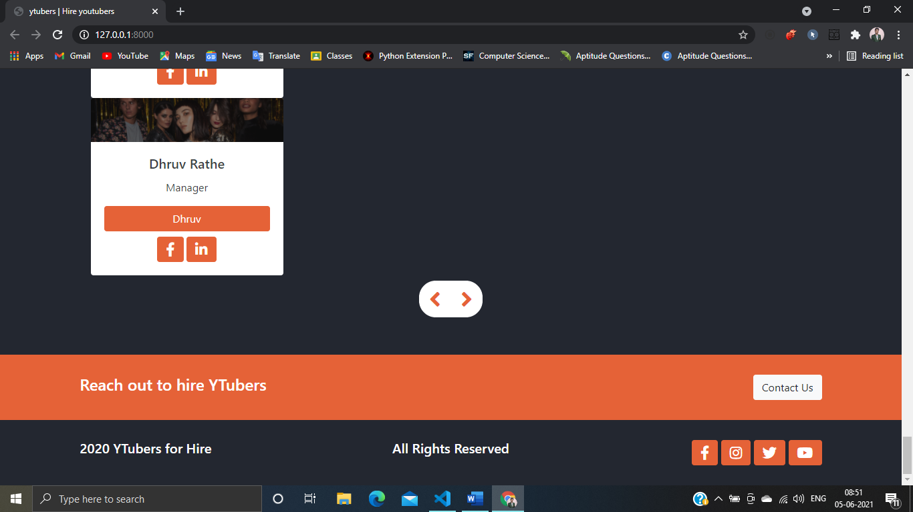

Figure 4.1.3

Login & Signup page

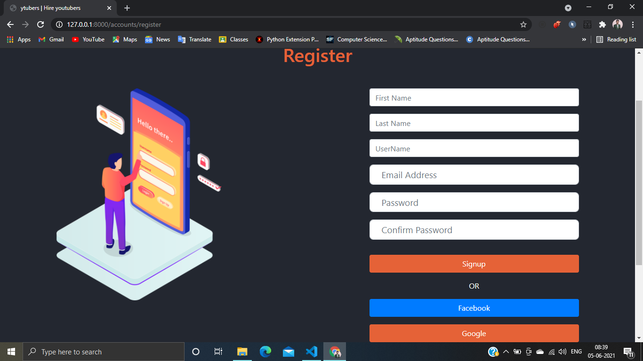

Figure 4.2.1

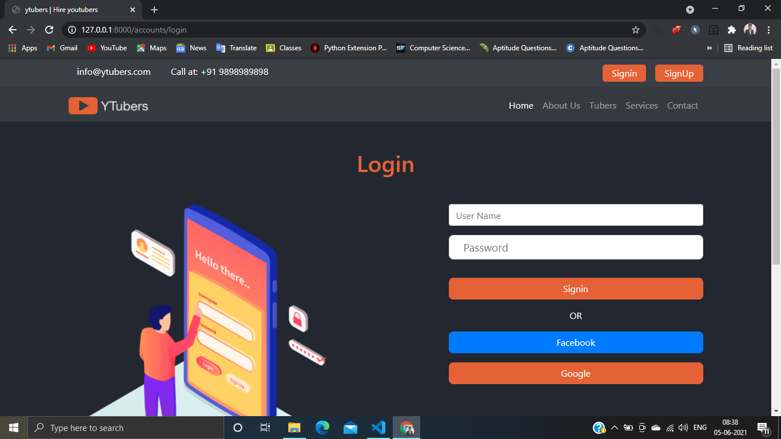

Figure 4.2.2

About Us

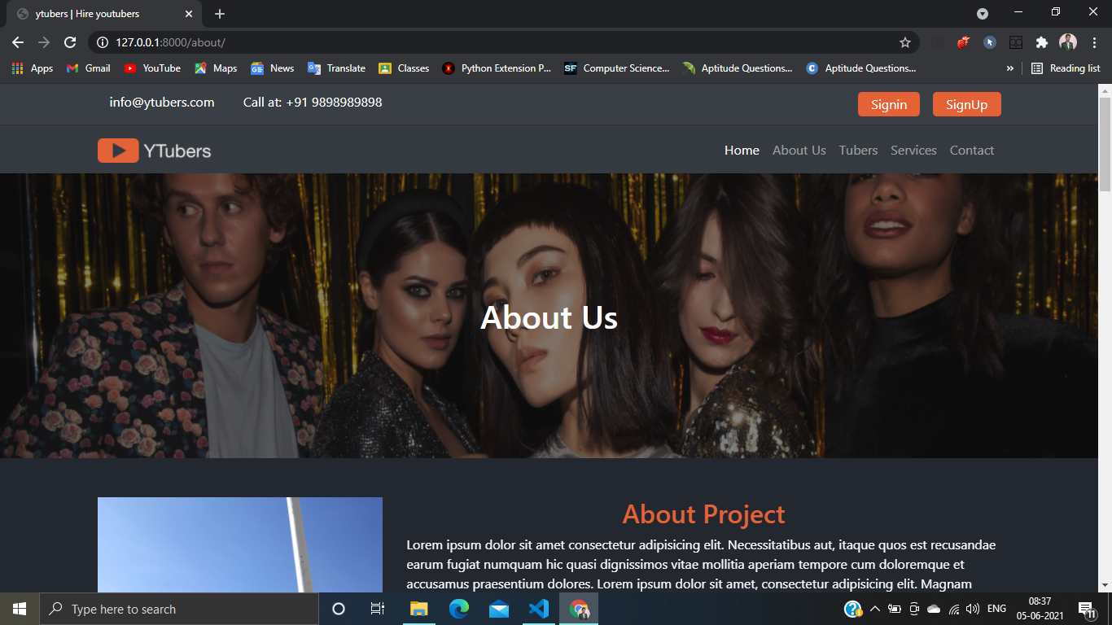

Figure 4.3.1

Tubers

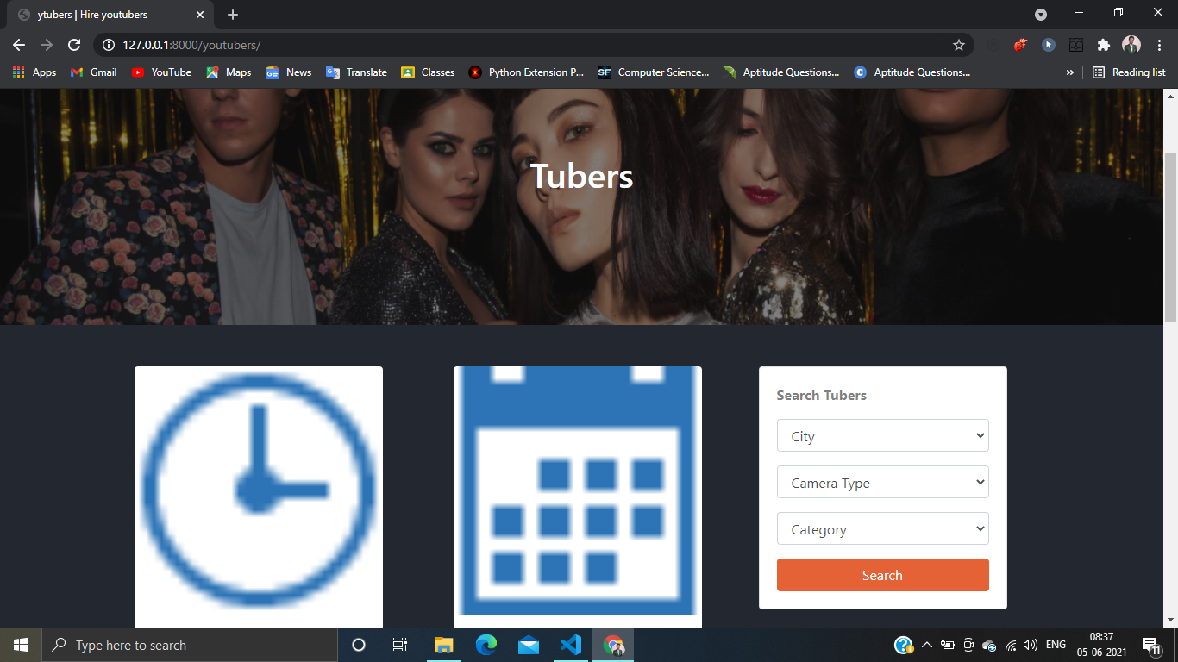

Figure 4.4.1

Description

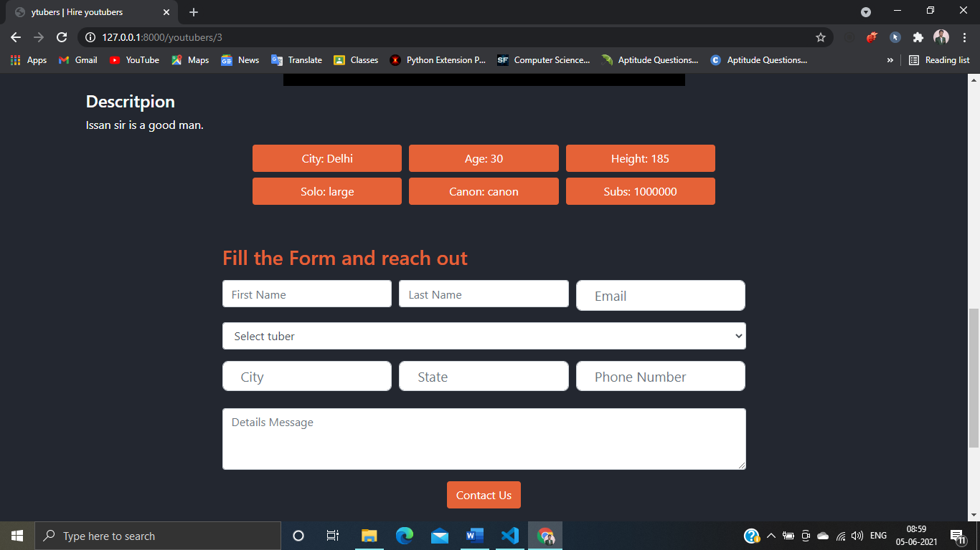

Figure 4.5.1

1. **CONCLUSIONS/ RECOMMANDATIONS**

* As you seen above screenshots in the result we have successfully made our web App and it is ready to use.
* We think the test are properly working login and signup with security are working smoothly.
* Our Web App is working properly in mobiles and PC’s.
* As We Recommend for the future, we add some more feature for payment gateway as Introduction of UPI’s etc.
* We can also host this web App.

# REFERENCE

* www.learncodeonline.in
* YouTube
* Self-Notes
* [www.Stackoverflow.com](http://www.Stackoverflow.com/)

# APPENDICES

## Details of Software

Visual Studio Code is a lightweight but powerful source code editor which runs on our desktop and is available for Windows, macOS and Linux.

It comes with built-in support for JavaScript, TypeScript and Node.js and has a rich ecosystem of extensions for other languages (such as C++, C#, Java, Python, PHP).

It fully complied our project till the end.

## Steps to Execute and Run

Step-1 launch VS code. Step-2 Activate the shell. Step-3 Go to Project

Step- 4 Execute by command “python manage.py runserver”.

Step-5 After step-4 link will come on double clicking on link browser will open and here we go.

## Coding

(1) python manage.py runserver.

Appendix 1